Six Aims Patch Award Ceremony
Patch Awards for those who learned the Six Aims
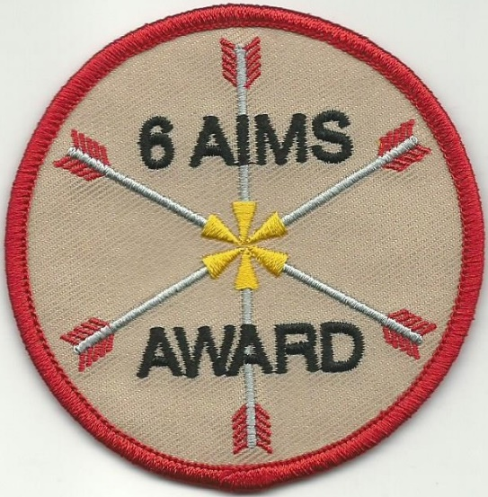
Overview: This ceremony can be performed generally on its own or within a larger ceremony, probably in the springtime. Throughout the program year, the child membership is encouraged to learn the Six Aims. If they are able to recite the Aims to an officer (Tribe Chief, Longhouse Officer, etc.) they are awarded a special patch to commemorate this achievement.
Instead of just handing the child a patch at the time they recite the Aims, this ceremony makes a larger more special event of it. When the child recites the Aims to the officer, the officer documents this on a special form, which is saved for the later ceremony.

A Six Aims award patch is available from patch vendors that support Native Sons & Daughters Programs. The Longhouse would purchase these for presentation at this ceremony.
A sample award program flyer and form is included on the last page of this ceremony document.

Participants:
- Longhouse Chief, or other as the leader/main presenter.
- Assistants as desired.

Six Aims Patch Award Ceremony
LEADER:
(Shouts Longhouse Salutation)
We have a special purpose to call forward the following Sons & Daughters.
(Without prior warning, call the Sons & Daughters forward, to assemble as instructed one at a time by their Indian name and Tribe name.)
I call on the attention of this special gathering of the (Longhouse Name) Longhouse. I ask you to take note of the Sons & Daughters standing here before you.
The Six Great Aims of the Native Sons & Daughters Programs have long been a guide for teaching of respect of others, care of Mother Earth, and love of family and fellow man. They are a long-standing part of the traditions of the Native Sons & Daughters Programs. These Aims, gifted to the program by the Friday family so long ago, are deeply rooted in the Native American culture as well as the cultures of those of us gathered here.
(Have entire group recite the Six Aims if desired)
(Looking at the Sons & Daughters called forward) You young Sons & Daughters have taken the time to learn these Six Aims and have demonstrated your knowledge of these Aims throughout the year. This is a special accomplishment that you can be proud of and that your father can be proud of. Take pride in knowing that this accomplishment is very pleasing to the eyes of the Great Spirit.
As (Officer position title) of the (Longhouse Name) Longhouse, it is my honor to bestow upon you young Sons & Daughters, this special Six Aims patch award, along with this ceremonial smudging, to honor what you have accomplished.
(Presentation of patches, smudging)
(Sacred Tree of Life poem) BELOW
(Closing words & congratulations)
(Shout Longhouse Salutation and exhort applause from the Nation)

Sacred Tree of Life
Sacred tree of life, teach us to root our self and walk in balance.
Teach us to share our shelter, food and our breath.
Teach us to bend, and to have compassion and love for our brothers and sisters.
Teach us to be grateful for all the gifts we receive and, remind us to pray.
Teach us to stand tall and reach for grandfather sun.
Teach us to share and live as one.
Sacred tree of life, thank you for all your wisdom and life which you provide.
Running Elk Woman
Contributed by: The Cheyenne Nation, Bedford OH

Sample flyer & form…
THE SIX AIMS AWARD
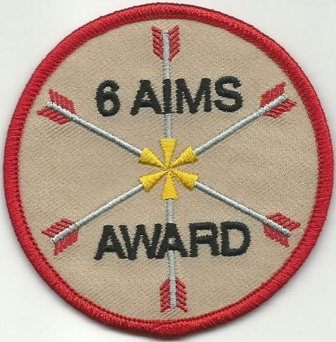
A special patch is available to honor all Native Sons & Daughters who successfully learn, memorize, and recite the Six Great Aims of the Native Sons & Daughters Programs. Longhouses or even Tribes may wish to implement this award as a standard practice to encourage and continue the legacy of this ritual/life lesson. The purpose of this award is to engrain the Aims of the program into memory, letting the Aims be a guide to each Son or Daughter. This award can only be earned ONCE during the child’s time in the program. There is no pressure to earn it at any specific time. The Six Aims award patch can be presented to those who have earned it in a special presentation once per year. A sample presentation ceremony is available on request. The patch shown below is available through the Patch Store/CQ Industries.

The Six Great Aims of the Native Sons & Daughters Programs:
- To be PALS FOREVER/Friends Always, father and child (son or daughter).
- To be clean in body and pure in heart.
- To love the sacred circle of the family.
- To love my neighbor as myself.
- To listen while others speak.
- To seek and preserve-the beauty of the Great Spirit's work-in forest, field, and stream.

Suggested Basic Rules for Testing a Son or Daughter’s ability to recite the Aims:
- The child must be able to recite the basic structure of each Aim sentence.
- The child does not have to recite the Aims in the order listed above, any order is fine.
- The method in which the testing is done is flexible, and relies on the honesty of the father or parent who is testing the child. No coaching or clues at the time of recital. If the child cannot complete all six aims, encourage them to study more, then try again.
- Testing must be done on a one-to-one basis. It can be done at home, at a tribe meeting or other. The point is that when a child is trying to recite the Aims, no other children should be close enough to hear what is being said.
- It may be a good idea to have the child say the Aims at several different times before counting the recital as official.
- Use an official form to notify the Council Awards Chief. A sample form is below.
- To preserve honesty, the Council/Awards Chief reserve the right to independently test any child whose name has been submitted for the award on their ability to recite the Six Aims.

-------------------------------------------------------------------------------------------------------------------------------------------------------

SAMPLE FORM: Please complete the following:

I / We hear-bye certify that the following Native Son/Daughter (child’s full name and Indian Name)

_______________________________of the _________________________tribe has successfully memorized and has recited without help, the Six Great Aims of the Native Sons & Daughters Programs. The recital of the above Six Aims was accomplished in my / our presence on (date) ___/___/___.

Signed (name and relation or position) ______________________________________________________________

Signed (name and relation or position) ______________________________________________________________
Second signature is not mandatory.

IMPORTANT DEADLINE:
For the program year XXXX, this form is to be turned in to the Awards Chief no later than XX/XX/XXXX

